# File permissions in Linux

## Project description

Manage authorization

## Check file and directory details

Enter ls command to check the file and directory detail

## Describe the permissions string

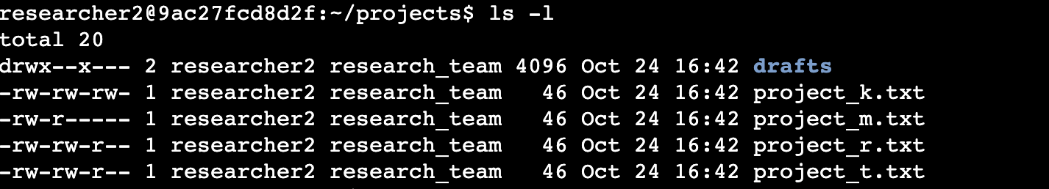Enter ls -l command to see the permissions string

## Change file permissions

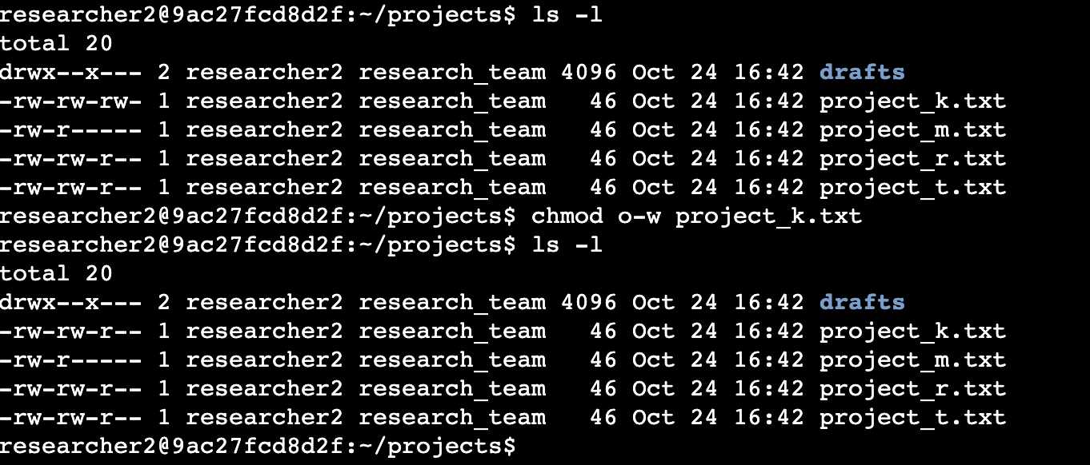Enter ls -la command to see the hidden files

## Change file permissions on a hidden file

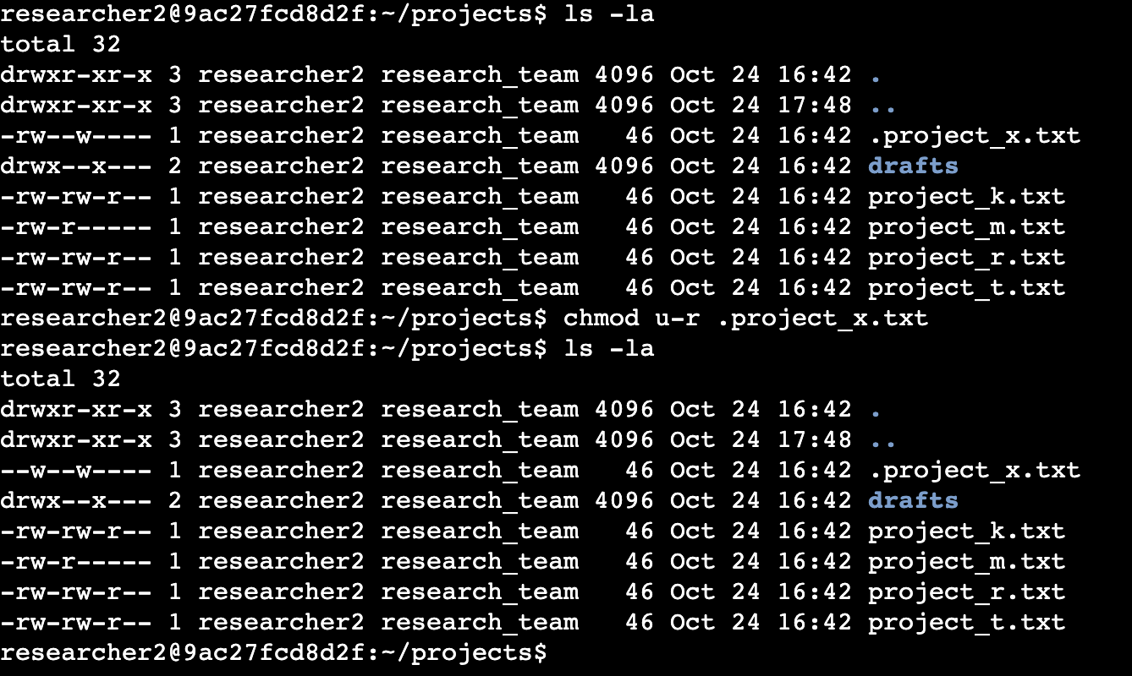Enter the chmod command to change the permissions

= to assign the permissions

+ to add the permissions

- to remove the permissions

## Change directory permissions

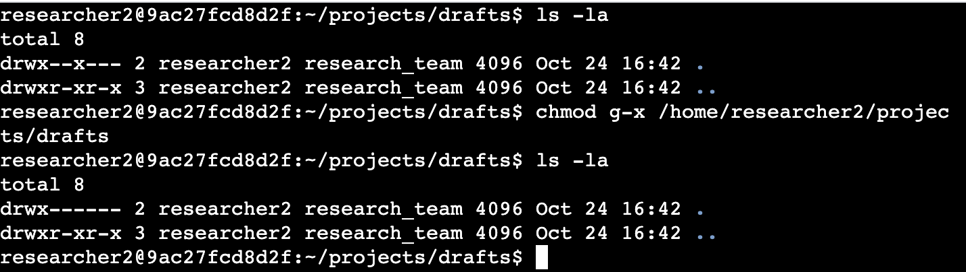Enter cd command to navigate between directories

Enter chmod to change the permissions on the directory

## Summary

In this project, I used ls commands to display the name of the files. I used ls -l commands to open the files and hidden files. I used ls -la commands to hide files. Then, I used the chmod command to change the permissions and assign permissions by using = command to assign, + to add, and - to remove.